FROM SOUTHERN SERENITY TO NORTHERN GRANDEUR
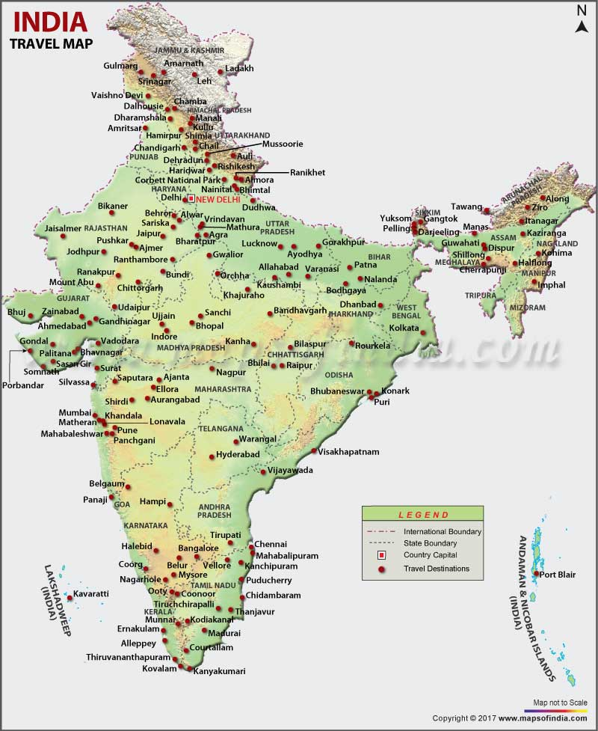

12 JUL’27 | DAY 01 | ARRIVE DELHI
Meeting and assistance upon arrival at Delhi International Airport transfer to hotel in Delhi. Upon arrival check in at hotel in Delhi.

Delhi – Where Centuries of History Meet the Pulse of Modern India: Few capital cities in the world possess a history as rich, captivating, and enduring as Delhi, the timeless capital of India. For over a millennium, this legendary city has stood at the crossroads of empires, drawing successive dynasties—including the Mongols, Turks, Persians, Afghans, Mughals, and the British—each leaving behind an extraordinary architectural, cultural, and historical legacy that continues to define the city's unique character.

Dinner & overnight stay at hotel in Delhi
13 JUL’27 | DAY 02 | DELHI
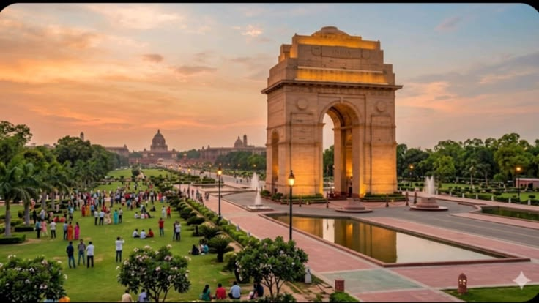
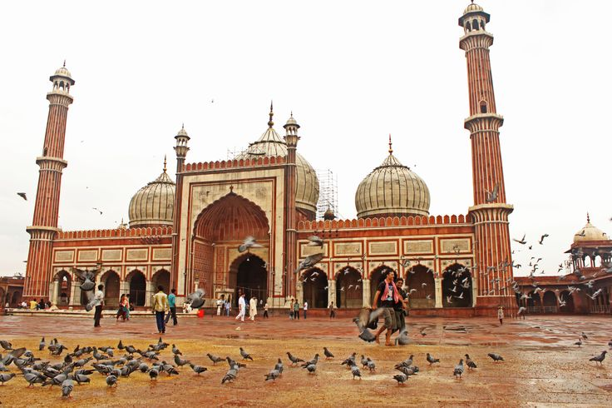
Morning after breakfast proceed for Delhi Sightseeing – A Journey Through the Capital’s Heritage: Explore the contrasting character of New Delhi and Old Delhi, where grand colonial architecture, magnificent monuments, vibrant bazaars, and centuries of history come together to reveal the many facets of India’s capital. Begin your exploration of New Delhi, distinguished by its elegant British colonial architecture, broad tree-lined avenues, landscaped boulevards, and stately government buildings. Visit the Laxminarayan Temple (Birla Mandir), a beautifully designed modern Hindu temple known for its graceful architecture and spiritual ambience. Continue to India Gate, the imposing 42-metre-high war memorial arch that stands as one of the most recognisable landmarks of the capital. Drive past the magnificent Parliament House and the Secretariat buildings, followed by the impressive Rashtrapati Bhavan, the official residence of the President of India. Together, these monumental structures reflect the architectural grandeur and historic evolution of New Delhi. Continue to Qutub Minar, one of Delhi’s most celebrated monuments and a UNESCO World Heritage Site. Rising majestically against the Delhi skyline, this remarkable medieval tower is adorned with intricate carvings and inscriptions, standing as a magnificent testament to the architectural and cultural heritage of the period.

The experience then takes you into the vibrant heart of Old Delhi, beginning with a visit to the historic Jama Masjid, commissioned in the 17th century by Mughal Emperor Shah Jahan. Its impressive courtyards, soaring minarets, and red sandstone and marble architecture make it one of the finest examples of Mughal religious architecture in the city. Continue to Chandni Chowk, the historic commercial heart of Old Delhi, where narrow lanes, colourful markets, traditional shops, street-food stalls, and the lively rhythm of everyday life create an unmistakably authentic Delhi experience. A drive past the magnificent Red Fort, with a brief photo stop, offers a glimpse of another great symbol of the Mughal era. Conclude the sightseeing at Raj Ghat, the serene memorial marking the cremation site of Mahatma Gandhi. Set amidst peaceful landscaped gardens, it provides a quiet and reflective conclusion to a day spent discovering Delhi’s remarkable history and heritage

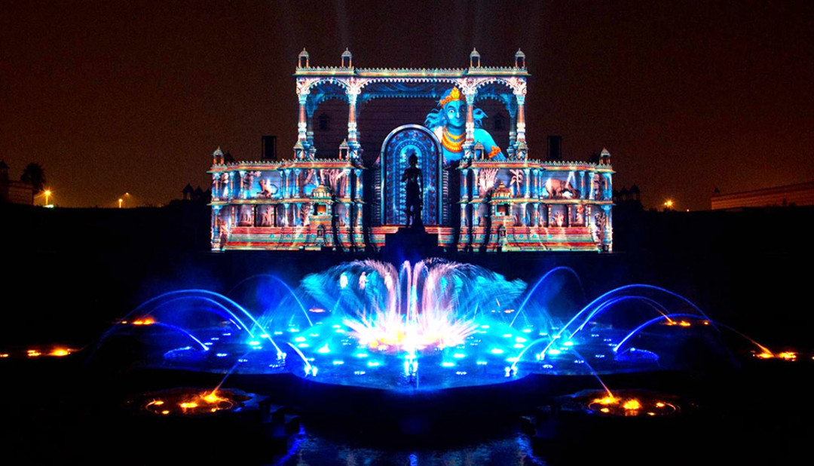
Afternoon proceed for an astonishing and beautiful fountain show at Akshardham Temple
As twilight descends, visitors are invited to take their seats within the magnificent step-well amphitheatre of Swaminarayan Akshardham Temple and immerse themselves in an experience that transcends time and reality. The Sahaj Anand Water Show unfolds as a profound journey into eternal truths, where storytelling, spirituality, and cutting-edge technology converge in perfect harmony. Set within the grand Yagnapurush Kund—a stunning replica of traditional Indian step-wells spanning. At its focal point lies a sacred nine-lotus design, inspired by ritual yantras used in Hindu ceremonies, symbolizing cosmic harmony. Presiding over this majestic space is the 27-foot-tall bronze murti of Neelkanth Varni, whose serene presence evokes inspiration, devotion, and inner strength. The 24-minute presentation is a breathtaking orchestration of multi-sensory elements, seamlessly blending multi-colour lasers, high-definition projections, dynamic water jets, underwater flames, surround sound, and live performances. Together, they bring to life a timeless narrative drawn from the ancient Kena Upanishad, one of the most revered texts of Vedic wisdom. The story unfolds with the playful innocence of children by a tranquil lake, whose joy and creativity give rise to a delicate flower formed from water. However, their lighthearted celebration inadvertently disturbs the devas—the powerful gods of the elements—who are reveling in their triumph over evil. What follows is a compelling interplay between humility and pride, innocence and power, as the fragile beauty of the children’s creation stands threatened by divine wrath. This extraordinary presentation, crafted through the collaboration of international experts alongside dedicated BAPS volunteers and sadhus, is far more than a visual spectacle. It is a deeply moving spiritual experience that resonates with audiences of all ages, leaving them inspired, introspective, and enriched.

Dinner & overnight stay at hotel in Delhi

14 JUL’27 | DAY 03: | DELHI – VARANASI (6E 2361 – 12:55HRS / 14:20HRS)
Morning after breakfast proceed to airport to board flight for Varanasi. Meeting and assistance upon arrival at Varanasi airport and transfer to hotel in Varanasi.

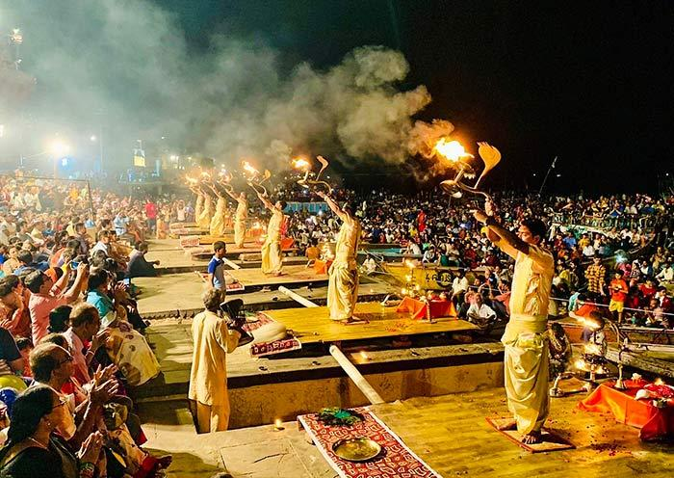
Evening witness Ganga Aarti – A Sacred Celebration of Life and Devotion: The Ganga Aarti is far more than a traditional religious ceremony; it is a deeply moving communal experience through which devotees express reverence, gratitude, and devotion to the sacred River Ganges. As evening descends upon the ghats of Varanasi, the riverfront comes alive with the glow of ceremonial lamps, devotional chants, incense, and the rhythmic sound of bells, creating an atmosphere that is both vibrant and profoundly spiritual. One of the most beautiful moments comes when devotees and visitors release small floating lamps, or diyas, onto the river. Each glowing lamp carries a personal prayer, heartfelt wish, or expression of gratitude, gently drifting across the waters and transforming the Ganges into a shimmering stream of light. The simple act creates a powerful connection between the individual, the sacred river, and the timeless traditions of Hindu spirituality.

Dinner & overnight stay at hotel in Varanasi

15 JUL’27 | DAY 04: | VARANASI
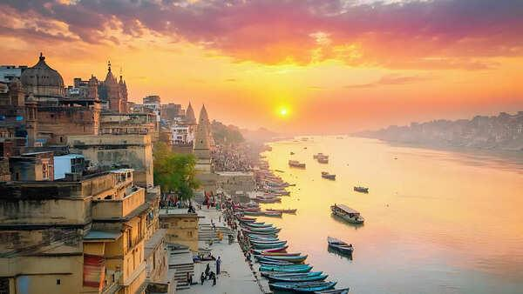
Sunrise Boat Ride on the Ganges & Visit to Vishwanath Temple: Begin the day with an early morning boat ride on the sacred River Ganges, one of the most evocative experiences in Varanasi. As the first rays of sunlight gently illuminate the riverfront, the ancient ghats gradually awaken, revealing a timeless panorama of spirituality, devotion, and daily life. From the tranquil waters, witness pilgrims gathering along the ghats to bathe in the holy river, offer prayers, and perform traditional rituals. The sight of devotees carrying out centuries-old practices against the backdrop of Varanasi’s historic riverfront offers a deeply atmospheric glimpse into the spiritual traditions that continue to shape the city. As the sun rises above the horizon, the changing light casts a golden glow across the river and the centuries-old architecture lining its banks. Seen from a boat, this peaceful moment creates a quietly uplifting and contemplative experience, allowing visitors to appreciate Varanasi from an entirely different perspective. The boat journey also offers views of the city’s cremation ghats, where ancient Hindu funeral traditions continue to be observed. These sacred spaces provide a profound insight into the Hindu understanding of life, death, and the eternal cycle of existence. Visitors are encouraged to observe respectfully and discreetly. Later, visit the revered Shri Kashi Vishwanath Temple, one of the most sacred temples dedicated to Lord Shiva. Often referred to as the Golden Temple because of its distinctive gold-plated towers, the temple holds immense spiritual significance for Hindu devotees.

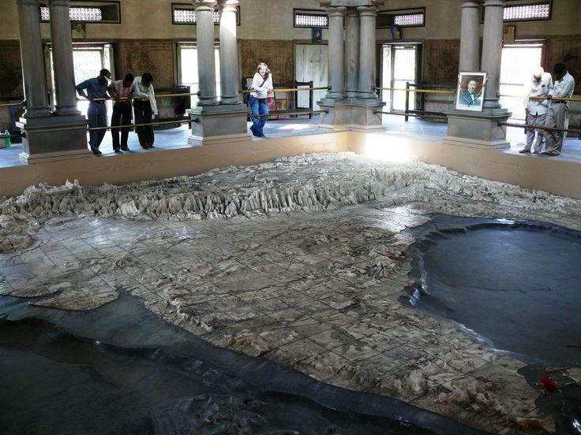
Return back to hotel for freshen up, have your breakfast and get ready for Varanasi Heritage & Temple Tour: Discover another fascinating facet of Varanasi on a half-day exploration through its spiritual heritage, religious traditions, architecture, and intellectual legacy. Beyond the sacred ghats of the Ganges, this experience introduces visitors to a remarkable collection of temples and cultural landmarks that reflect the city’s enduring importance as a centre of faith and learning. Begin with a visit to the Bharat Mata Temple, a unique temple dedicated not to a traditional deity but to the spirit of India itself. Its principal attraction is an impressive three-dimensional marble relief map of India, offering a distinctive representation of the country’s geographical landscape and making the temple a fascinating cultural experience. Continue to the Durga Temple, an elegant shrine dedicated to Goddess Durga and distinguished by its striking red-coloured architecture. The visit is followed by the Tulsi Manas Temple, a modern marble temple associated with the revered poet-saint Goswami Tulsidas. Its walls are beautifully inscribed with verses and scenes from the Ramcharitmanas, the celebrated Hindi rendition of the Ramayana, bringing the epic’s timeless teachings to life through art and literature. The tour continues to the New Vishwanath Temple, situated within the grounds of Banaras Hindu University and known for its impressive height and distinctive architecture. The temple is dedicated to Lord Shiva and is an important spiritual landmark of the university campus. Non-Hindus are not permitted inside the temple. Drive through the expansive campus of Banaras Hindu University (BHU), one of India’s most renowned centres of education and learning, and visit its museum, which offers further insight into the artistic and cultural heritage of the region. Conclude the tour with a view of the Alamgir Mosque, traditionally associated with the Mughal Emperor Aurangzeb. Perched above the Ganges, the mosque presents an intriguing architectural contrast and adds another historical layer to Varanasi’s extraordinarily diverse cultural landscape.
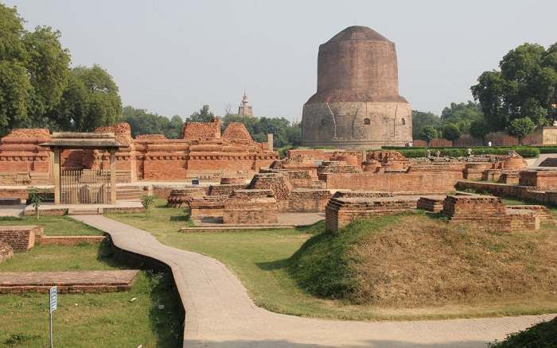
Afternoon explore Sarnath, one of the most revered Buddhist pilgrimage sites in India and a place of profound historical and spiritual significance. Located just outside Varanasi, Sarnath is traditionally regarded as the site where Gautama Buddha delivered his first sermon after attaining enlightenment, setting in motion the teachings that would become the foundation of Buddhism. The visit begins with the archaeological ruins, dominated by the magnificent Dhamek Stupa, an imposing structure believed to mark the spot where Buddha delivered his first sermon to his five disciples. Rising prominently from the surrounding ruins, the stupa stands as a powerful symbol of Buddhism and attracts pilgrims and visitors from across the world. Continue through the remains of the ancient monasteries and temples, which offer a fascinating glimpse into Sarnath’s past as an important centre of Buddhist learning and spiritual practice. Among the archaeological treasures is the remains of the Ashoka Pillar, erected during the reign of Emperor Ashoka and originally rising more than 20 metres. Its celebrated Lion Capital, now preserved in the Sarnath Museum, has become one of the most recognisable symbols of India and forms the inspiration for the country’s national emblem. A visit to the Sarnath Museum provides an opportunity to admire the remarkable collection of sculptures, archaeological discoveries, and artefacts unearthed from the surrounding site. Among its most prized exhibits is the exquisitely carved Lion Capital of Ashoka, renowned for its artistic refinement and historical significance.

Dinner & overnight stay at hotel in Varanasi

16 JUL’27 | DAY 05: | VARANASI – KHAJURAHO (VANDE BHARAT EXPRESSS – 05:15Hrs / 13:10Hrs)
On time transfer to Varanasi station to board train for Khajuraho. Meeting and assistance upon arrival at Khajuraho station and transfer to hotel. Upon arrival check in at hotel in Khajuraho.

Khajuraho – A Masterpiece of Art, Architecture & Human Expression: The magnificent temples of Khajuraho, built under the patronage of the Chandela dynasty between the 10th and 11th centuries, stand among India’s most extraordinary expressions of medieval architecture, sculpture, and artistic imagination. Once part of a much larger temple complex, the surviving group of temples today offers a remarkable window into the cultural, spiritual, and artistic sophistication of Central India during the Chandela period. Adorned with an astonishing array of finely sculpted figures and intricate ornamental details, the temples portray the many dimensions of human existence—from devotion, music, dance, and everyday life to love and sensuality. The celebrated erotic sculptures, found among the wider repertoire of carvings, have attracted considerable attention and interpretation since the temples were brought to wider international notice following their rediscovery by British officer T. S. Burt in 1838.

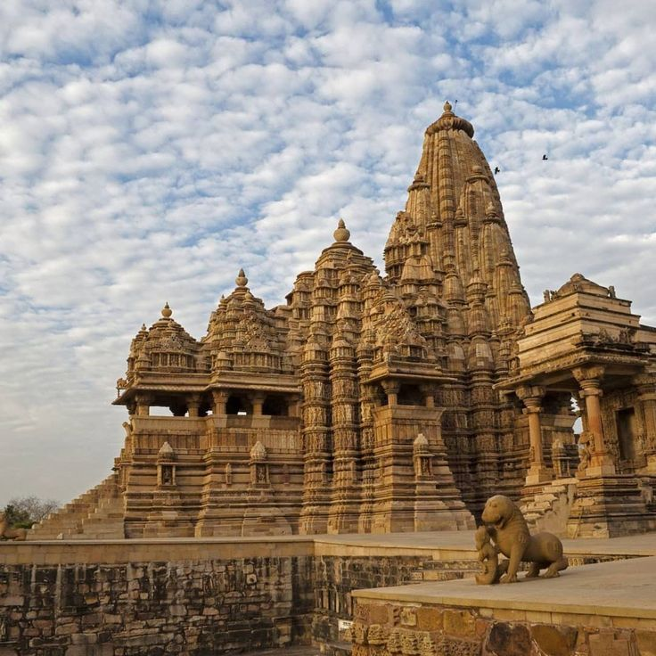
Afternoon proceed for tour of Khajuraho – A Journey Through Sacred Art & Architectural Splendour: Embark on a fascinating half-day exploration of the Western and Eastern Groups of Temples at Khajuraho, an extraordinary ensemble celebrated for its magnificent architecture, intricate stone carvings and remarkable artistic expression. Begin with the Western Group of Temples, the most celebrated collection at Khajuraho. The highlight is the magnificent Kandariya Mahadev Temple, rising nearly 32 metres and adorned with an astonishing profusion of finely carved sculptures. Its walls and facades portray an extraordinary range of subjects, from divine figures, musicians and celestial beings to scenes depicting love, beauty and sensuality, reflecting the sophisticated artistic vision of the Chandela period. Continue to the Chaunsat Yogini Temple, one of the oldest surviving shrines at Khajuraho and notable for its distinctive granite construction. The Devi Jagadambi Temple, dedicated to the Mother Goddess, is admired for its graceful proportions and exquisite sculptural details. The Chitragupta Temple, dedicated to Surya, the Sun God, is particularly distinguished by its impressive image of the deity and beautifully sculpted exterior. Together, these temples offer a captivating glimpse into the religious beliefs, artistic traditions and cultural sophistication of medieval India. Continue to the Eastern Group of Temples, where Hindu and Jain traditions exist harmoniously within the same sacred landscape. The magnificent Parsvanath Temple, the largest and finest of the Jain shrines, is renowned for its elegant architecture and exceptionally detailed carvings. Also visit the Adinatha Temple, dedicated to the first Jain Tirthankara, as well as the beautifully ornamented Ghantai Temple and the Vamana Temple, dedicated to Lord Vishnu in his Vamana incarnation. A visit to Khajuraho is far more than an architectural excursion; it is an encounter with a remarkable chapter of Indian history where faith, craftsmanship, mythology and human expression were transformed into enduring works of art carved in stone

Dinner & overnight stay at hotel in Khajuraho

17 JUL’27 | DAY 06: | KHAJURAHO – ORCHHA (173Kms, 02Hrs drive)
Morning after breakfast drove to Orchha. Upon arrival check in at hotel in Orchha.

Orchha – A Timeless Legacy of the Bundelas: Located approximately 26 km from Jhansi, Orchha is a captivating medieval town founded in 1531 by the Bundela rulers on the serene banks of the Betwa River. Remarkably untouched by the passage of time, Orchha preserves an exceptional collection of magnificent palaces, temples and monuments dating primarily from the 16th and 17th centuries, offering a fascinating glimpse into the grandeur and heritage of medieval India. The town is perhaps best experienced through its impressive fort-palace complex, where imposing stone walls enclose a remarkable world of courtyards, gardens, gateways, pavilions and temples. Rising above the complex are elegant chhatris (cenotaphs) and richly ornamented battlements, creating an enchanting silhouette against the surrounding landscape. The harmonious blend of Rajput architectural traditions, Mughal influences and intricate artistic detailing gives Orchha a distinctive character found nowhere else.
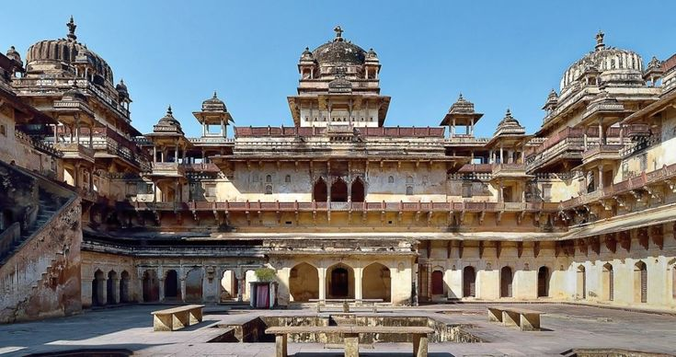
Afternoon proceed for sightseeing tour of Orchha – Palaces, Temples & Living Heritage: Explore the magnificent architectural treasures of Orchha, beginning with the Jahangir Mahal, an imposing palace built as a harmonious synthesis of Hindu and Islamic architectural traditions. Its grand courtyards, elegant domes, ornate balconies and finely crafted details reflect the cultural exchange and artistic refinement of the Bundela era. Continue to the Raj Mahal, one of Orchha's oldest royal residences, renowned for its beautifully preserved murals depicting scenes from Hindu mythology, royal life and religious traditions. The intricate paintings offer a fascinating insight into the artistic heritage and devotional spirit of the Bundela court. Visit the revered Ram Raja Temple, a unique palace-turned-temple and one of Orchha's most distinctive landmarks. Here, Lord Rama is worshipped as a king, giving the temple an extraordinary character that blends royal traditions with deep religious devotion. Admire the imposing Chaturbhuj Temple, an architectural masterpiece originally conceived for Lord Rama and later associated with Lord Vishnu. Its distinctive cruciform plan, soaring structure and monumental proportions make it one of Orchha's most impressive landmarks. Conclude with a visit to the Lakshminarayan Temple, dedicated to Goddess Lakshmi and particularly admired for its remarkable murals. The temple beautifully combines the architectural character of a temple with the defensive elements of a fort, while its well-preserved paintings add an exceptional artistic dimension to the experience.

Dinner & overnight stay at hotel in Orchha

18 JUL’27 | DAY 07: | ORCHHA – JHANSI (17Kms, 43Mnts drive) – AGRA CANTT (VANDE BHARAT EXPRESS
– 08:43Hrs /11:01Hrs)
On time transfer to Jhansi station to board train for Agra. Meeting and assistance upon arrival and transfer to hotel in Agra. Upon arrival check in at hotel in Agra.

Agra – Where History, Legend & Imperial Grandeur Converge: Situated gracefully on the banks of the Yamuna River, Agra is a city where centuries of history, legend and imperial splendour come together. Tradition attributes the foundation of the present city to Raja Badal Singh around 1475 AD, although references to Agraban in the Mahabharata suggest that the region has enjoyed significance since ancient times and was closely associated with Mathura, one of the oldest sacred cities of northern India. Agra rose to greater prominence during the rule of the Lodi dynasty, when Sikandar Lodi established it as his capital in the late 15th century, laying the foundations for its emergence as an important political and cultural centre of North India.

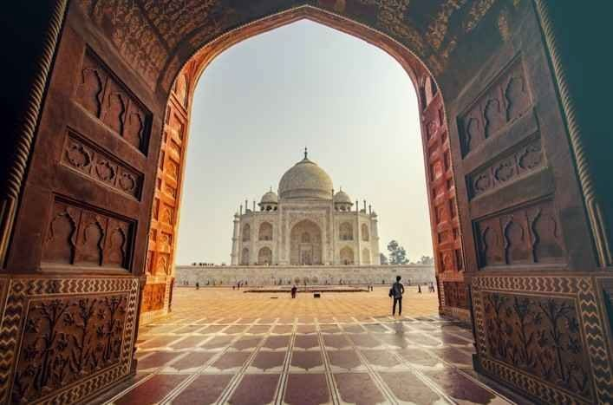
Afternoon proceed for sightseeing tour of Agra visiting The Taj Mahal – A Monument to Eternal Love: Following the death of his beloved wife Mumtaz Mahal in 1631, the Mughal emperor Shah Jahan, renowned for his passion for architecture and the arts, resolved to create a memorial of unparalleled beauty — a monument that would transcend time and remain forever etched in the memory of the world. The site was chosen with extraordinary thought. Set upon a bend of the Yamuna River, the location allowed the monument to be admired from Shah Jahan's royal quarters within Agra Fort, further upstream, creating a magnificent visual connection between the emperor's palace and the mausoleum. Construction of the Taj Mahal began in 1631, bringing together master architects, craftsmen, stonecutters, calligraphers, inlay artists and artisans from across the Mughal Empire and beyond. Over the course of approximately 22 years, thousands of skilled craftsmen worked to bring Shah Jahan's vision to life, creating one of the world's most celebrated masterpieces. Built predominantly in gleaming white marble, the Taj Mahal is a remarkable study in contrasts — monumental in scale yet extraordinarily delicate in detail, majestic in its overall conception yet refined in every carved and inlaid surface. Its perfectly balanced proportions, graceful domes, elegant minarets, intricate floral motifs and exquisite pietra dura work demonstrate an exceptional level of craftsmanship. More than an architectural masterpiece, the Taj Mahal has endured as a timeless symbol of love, remembrance and devotion.

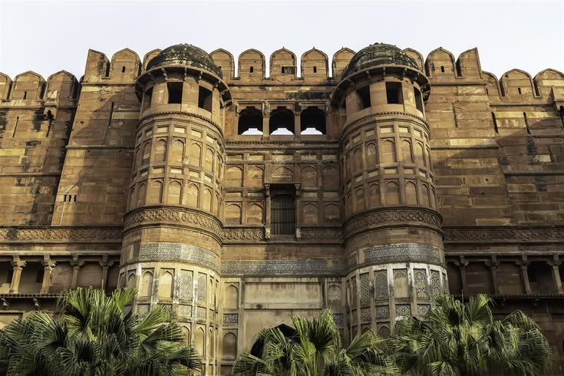
Agra Fort – A Citadel of Mughal Power & Grandeur: Begin your exploration of Agra's imperial heritage with the magnificent Agra Fort, whose construction was initiated by Emperor Akbar in 1565. Built primarily of imposing red sandstone, this vast fortified complex stretches for approximately 2½ kilometres, its formidable walls once protected by a broad moat and imposing gateways. Far more than a military stronghold, Agra Fort evolved into a magnificent city within a city, serving as a royal residence, administrative centre and seat of Mughal power. Within its massive walls lies an extraordinary collection of palaces, audience halls, mosques, gardens and architectural masterpieces, reflecting the changing tastes and ambitions of successive Mughal emperors. Among its principal highlights is the elegant Moti Masjid, or Pearl Mosque, admired for its serene white-marble architecture. The Diwan-i-Am, or Hall of Public Audiences, was where the emperor received his subjects and addressed matters of state, while the more intimate Diwan-i-Khas, or Hall of Private Audiences, was reserved for distinguished guests, nobles and important affairs of the empire. Also discover the Octagonal Tower, offering memorable views towards the Yamuna and the Taj Mahal, and Jahangir's Palace, one of the finest surviving residential structures within the fort, showcasing a harmonious blend of Hindu and Islamic architectural influences. Every courtyard, pavilion and intricately decorated chamber reveals another chapter of Mughal history, from Akbar's military vision to the architectural refinement of Shah Jahan's reign.

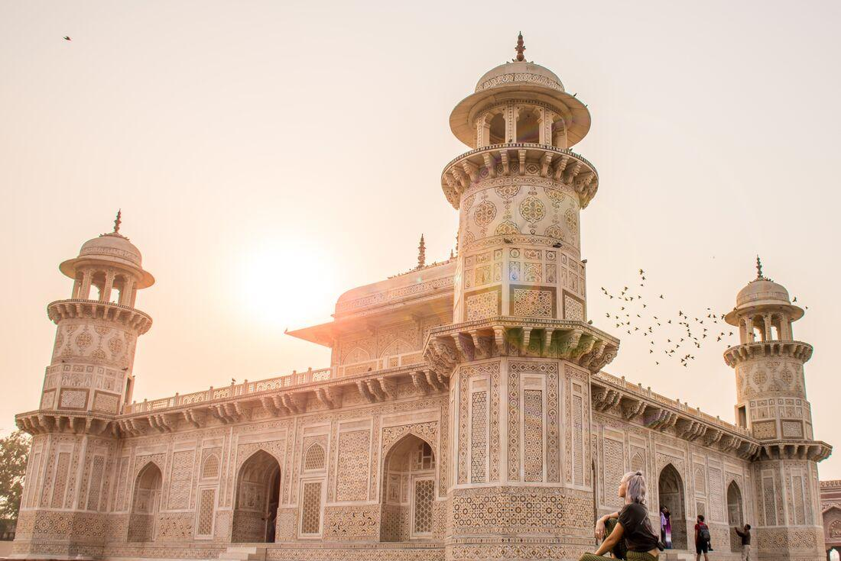
Itmad-ud-Daulah – The Delicate Jewel of Agra: Visit the exquisite Tomb of Itmad-ud-Daulah, built between 1622 and 1628 by Empress Nur Jahan in memory of her father, Mirza Ghiyas Beg, who served as an influential nobleman at the court of Emperor Jahangir. Gracefully set beside the Yamuna River, this elegant mausoleum is celebrated for its refined use of white marble, delicate lattice screens and intricate pietra dura inlay. It occupies a particularly important place in Mughal architectural history, as it is widely regarded as the first Mughal tomb to make extensive use of white marble and elaborate stone inlay, establishing an aesthetic that would later reach its magnificent expression in the Taj Mahal. Often affectionately referred to as the “Baby Taj,” the monument possesses a charm quite distinct from the monumental grandeur of its more famous neighbour. Its intimate scale, exquisite craftsmanship, symmetrical gardens and softly luminous marble create an atmosphere of remarkable peace and serenity. Take time to admire the intricate floral motifs, geometric patterns and translucent marble screens, each revealing the extraordinary skill of the artisans who transformed the mausoleum into a jewel-like work of art.

Dinner & overnight stay at hotel in Agra

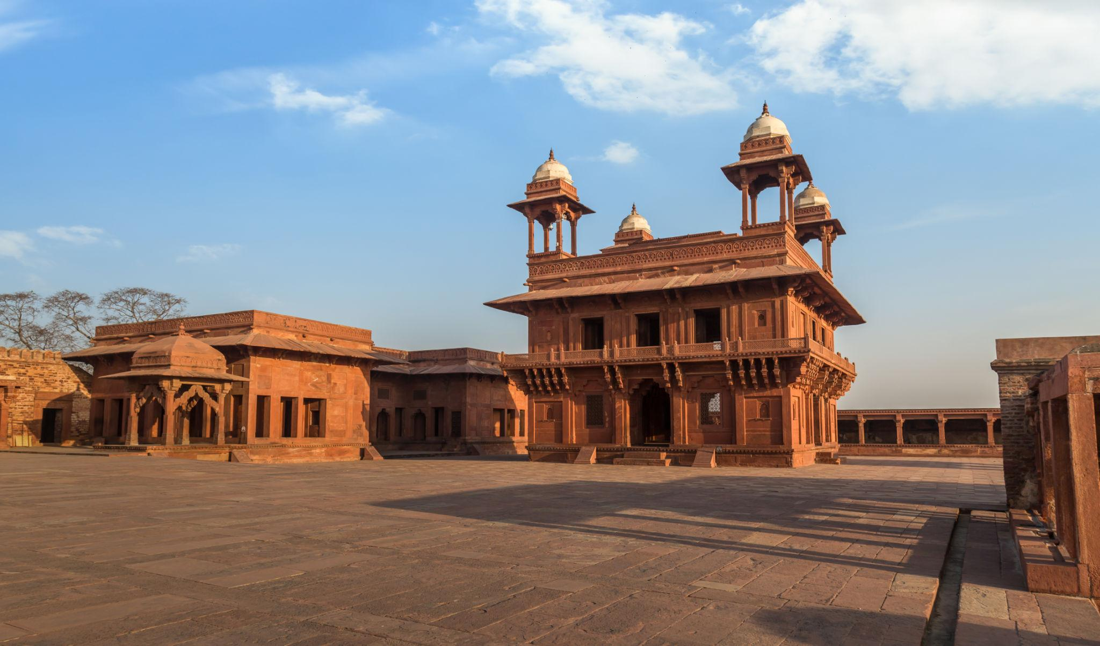
19 JUL’27 | DAY 08: | AGRA – FATEHPUR SIKRI – ABHANERI – JAIPUR (252Kms, 05Hrs drive)
Morning after breakfast drive to Jaipur enroot visiting Fatehpur Sikri – Akbar’s Vision in Stone: Explore the magnificent fortified city of Fatehpur Sikri, an extraordinary testament to the vision and architectural ambition of Emperor Akbar. Built in 1569 to serve as the Mughal emperor’s capital, the city flourished for only a few decades before being abandoned, traditionally attributed to a severe scarcity of water. Today, its remarkably preserved palaces, courtyards and religious monuments stand as a hauntingly beautiful reminder of the grandeur of the Mughal court. Within the imposing red sandstone complex, visit the magnificent Jami Masjid, one of the finest congregational mosques of the period, and the elegant tomb of Sheikh Salim Chishti, whose pristine marble screens and delicate craftsmanship create a striking contrast with the surrounding red sandstone. Continue to the Panch Mahal, an elegant five-storeyed pavilion whose progressively diminishing levels create a graceful, almost ethereal silhouette. The Diwan-i-Khas, or Hall of Private Audiences, is particularly notable for its extraordinary central pillar and richly carved architectural details. The complex also encompasses a fascinating collection of royal palaces, courtyards and pavilions associated with the imperial household.
What makes Fatehpur Sikri particularly remarkable is the way its architecture reflects the cultural synthesis of Akbar's reign. Islamic architectural principles blend seamlessly with Hindu and Jain decorative traditions, creating a distinctive style expressed through carved brackets, columns, geometric patterns, ornamental motifs and richly sculpted details.

Chand Baori, Abhaneri – An Architectural Wonder in Stone: Discover the extraordinary Chand Baori at Abhaneri, one of Rajasthan’s most remarkable examples of traditional water architecture. Believed to have been named after Raja Chanda of the Nikumbh dynasty, the origins of the stepwell remain undocumented, as no definitive epigraphic evidence has yet been found regarding its construction or that of the adjoining Harshat Mata Temple. Created in response to Rajasthan’s arid climate and the vital need to conserve and access water, Chand Baori combines remarkable engineering with extraordinary visual symmetry. Its vast geometric composition of precisely aligned steps descending deep into the earth creates an almost mesmerising architectural spectacle, while the surrounding structures and carved elements reflect the artistic traditions of early medieval Rajasthan.

Continue drive to Jaipur. Upon arrival check in at hotel in Jaipur.

Jaipur – The Pink City of Royal Grandeur: Founded in 1727 by Maharaja Sawai Jai Singh II, Jaipur, popularly known as the “Pink City,” is a remarkable blend of royal heritage, architectural brilliance and meticulous urban planning. Conceived as one of India's earliest planned cities, Jaipur was designed according to the principles of the ancient Shilpa Shastra, with the city divided into nine rectangular sectors, symbolically representing the nine divisions of the universe. The city's master plan was shaped by the vision of its architects, who combined traditional Hindu principles of architecture with the refined influences of Mughal and Jain design, creating a distinctive architectural identity that continues to define Jaipur today. Broad avenues, orderly streets, grand gateways and beautifully ornamented buildings reflect the extraordinary foresight behind its creation. In 1853, the city was famously painted in its characteristic terracotta-pink colour to welcome Prince Albert, who was visiting Jaipur as part of his tour of India. The colour was subsequently preserved as a symbol of hospitality and has become inseparable from the city's identity.

Dinner & overnight stay at hotel in Jaipur.

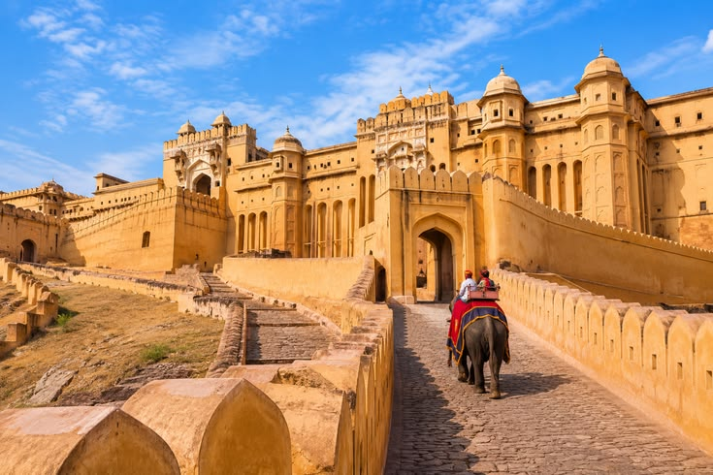
20 JUL’27 | DAY 09: | JAIPUR
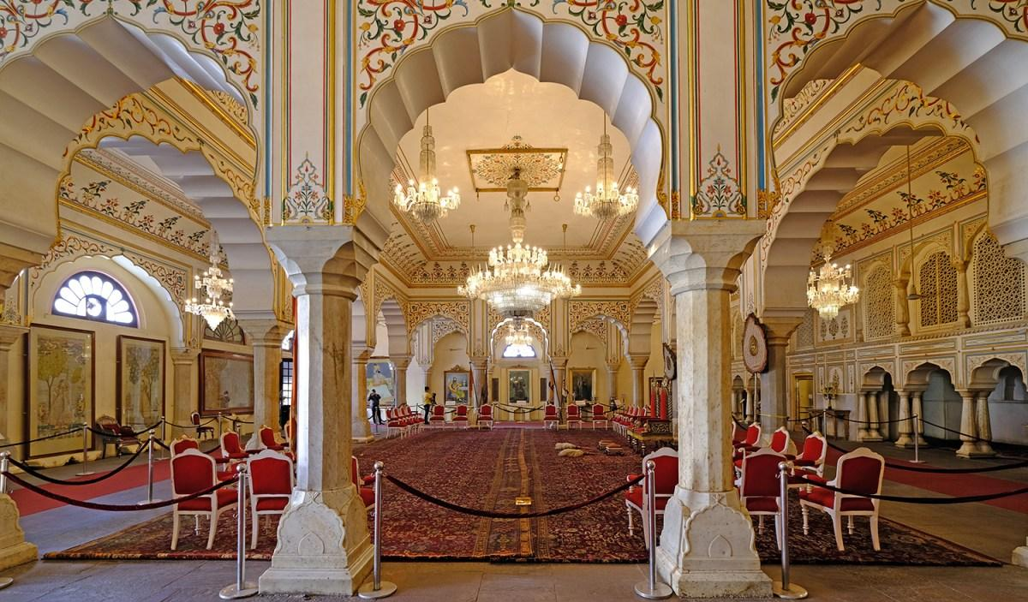
Morning visit Amber Fort – A Magnificent Legacy of the Rajputs: Visit the magnificent Amber Fort, the ancient capital and stronghold of the Rajput rulers, situated approximately 11 km from Jaipur. Dramatically perched on the rugged Aravalli hills and overlooking Maota Lake, this imposing fort-palace is one of Rajasthan's finest examples of Rajput architecture, where grandeur, artistry and strategic design come together in spectacular harmony. The construction of the fort was initiated by Raja Man Singh and it remained the principal seat of the Kachwaha Rajputs until Maharaja Sawai Jai Singh II moved the capital to the newly established city of Jaipur in 1727. Explore the fort's magnificent courtyards, palaces and ceremonial spaces, including the Diwan-i-Am, or Hall of Public Audience, where the ruler received his subjects. Visit the revered Kali Temple, an important spiritual centre within the fort, before proceeding to the exquisite Jai Mandir, or Hall of Victory. The Jai Mandir is particularly renowned for its delicate inlaid panels and dazzling mirror work, which create a magical effect when illuminated. Continue to Sukh Niwas, the pleasure palace, admired for its elegant architecture and ingenious cooling system. The beautifully designed interiors and surrounding courtyards offer a glimpse into the refined lifestyle of the Rajput royalty. From the elevated terraces and ramparts of Amber Fort, enjoy breathtaking panoramic views of Maota Lake, the surrounding hills and the historic landscape below.
Afternoon proceed for sightseeing tour of Jaipur City Tour – Royal Heritage & Astronomical Marvels: Take a half-day tour of Jaipur, exploring its magnificent royal heritage and extraordinary architectural landmarks. Begin with a visit to the Maharaja's City Palace, an impressive complex at the heart of the walled city. Built in the 18th century, the palace occupies a significant portion of Jaipur's historic centre and continues to reflect the grandeur and refinement of the former royal court. Explore the elegant Mubarak Mahal, now home to fascinating collections of textiles, costumes and royal artefacts, as well as the museums displaying an impressive array of arms and armour. Continue through the magnificent Diwan-i-Khas and Diwan-i-Am, the private and public audience halls respectively, where the architectural details offer an evocative glimpse into the ceremonial life of the Maharajas. Continue to the remarkable Jantar Mantar, Jaipur's celebrated astronomical observatory and a UNESCO World Heritage Site. Its name is traditionally interpreted as referring to instruments used to measure celestial harmony and movements. Built by Maharaja Sawai Jai Singh II, the observatory houses a remarkable collection of monumental astronomical instruments, each designed for a specific purpose and capable of remarkably precise observations. Together, they demonstrate the extraordinary scientific knowledge and astronomical curiosity of 18th-century India. Make a photo stop at the iconic Hawa Mahal, or “Palace of the Winds,” instantly recognisable for its delicate honeycomb façade and hundreds of small windows. Built to allow royal women to observe the lively streets and processions below while remaining unseen, it has become one of Jaipur's most enduring symbols. Complete the tour with a drive through Jaipur's distinctive rose-pink residential and commercial quarters, where historic façades, bustling bazaars and everyday city life combine to create the unmistakable character of the Pink City.

Dinner & overnight stay at hotel in Jaipur

21 JUL’27 | DAY 10: | JAIPUR – COCHIN (6E 6142 – 08:35Hrs / 14:00Hrs)
Morning on time transfer to Jaipur airport to board flight for Cochin. Meeting and assistance upon arrival at Cochin airport and transfer to hotel in Cochin. Upon arrival at hotel in Cochin.

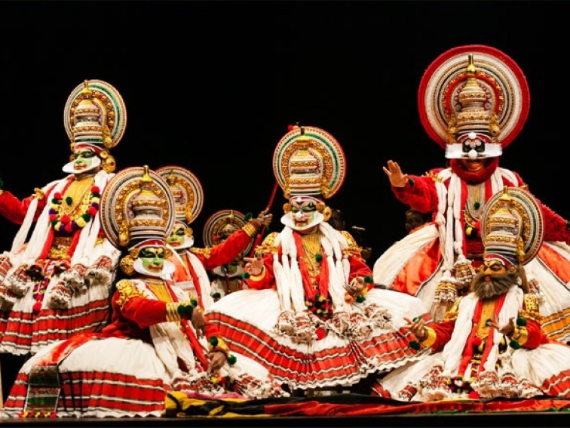
Evening witness Kathakali – The Enchanting Story Dance of Kerala: Experience the captivating world of Kathakali, Kerala’s celebrated classical dance-drama, whose name literally translates as “story dance.” Combining expressive acting, graceful yet powerful movements, elaborate costumes, and striking facial expressions, Kathakali transforms traditional stories and characters into a spectacular visual and emotional performance. At the heart of Kathakali is the remarkable ability of the performer to communicate without spoken dialogue. Every movement of the body, gesture of the hands, movement of the eyes, and subtle change in facial expression is carefully controlled to convey the thoughts, emotions, and character of the story. The result is a highly expressive art form in which dance, drama, music, and mime become seamlessly intertwined. Traditionally regarded as a predominantly male performing art, Kathakali is characterised by a distinctive and powerful physical vocabulary. Performers maintain a strong, angular posture, often with the knees bent and widely positioned, while the arms and hands are held in carefully defined gestures. Despite the demanding posture and intricate movements, the performer maintains remarkable balance, control, and precision throughout the performance. The experience is further enhanced by the performers’ elaborate costumes, intricate makeup, distinctive headgear, expressive eyes, and rhythmic accompaniment, creating an unforgettable theatrical spectacle.

Dinner and overnight stay at hotel in Cochin

22 JUL’27 | DAY 11: | COCHIN – MUNNAR (125Kms, 04Hrs drive)
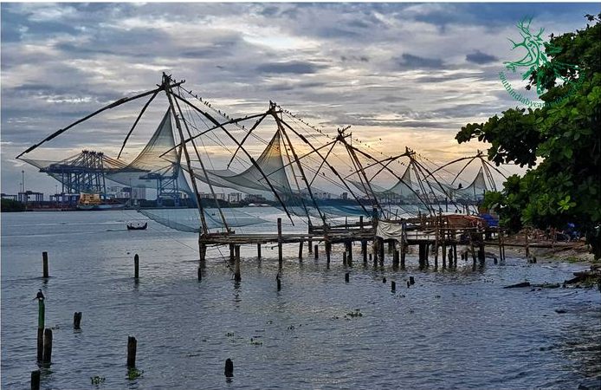
Morning after breakfast proceed for sightseeing tour of Cochin – A Tapestry of Colonial Heritage and Cultural Influences: Explore Cochin (Kochi), a historic port city where centuries of maritime trade have left behind a fascinating blend of Indian, European, Jewish, and Asian influences. The city’s distinctive character is reflected in its historic streets, remarkable architecture, and enduring cultural traditions. Begin with a visit to the magnificent Dutch Palace, also known as Mattancherry Palace, renowned for its exquisite collection of traditional Kerala murals depicting scenes from Hindu epics, mythology, and religious traditions. The palace offers a fascinating glimpse into Kerala’s royal heritage and the artistic excellence of its craftsmen. Continue to the historic Jewish Synagogue, located in the heart of the atmospheric Jew Town. Built in the traditional style and enriched with distinctive architectural details, the synagogue stands as an enduring symbol of the centuries-old Jewish heritage of Cochin. Explore the surrounding antique shops and historic lanes, which add to the unique character of this charming quarter. Proceed towards the waterfront to see Cochin’s iconic Chinese fishing nets, or Cheena Vala—ingenious cantilevered fishing structures believed to have been introduced by Chinese traders. Their dramatic silhouettes against the harbour create one of the city’s most recognisable and atmospheric sights. Continue to St. Francis Church, one of India’s oldest European-built churches. The church is particularly associated with the Portuguese explorer Vasco da Gama, who was originally buried here following his death in Cochin before his remains were later transferred to Portugal.

Later continue drive to Munnar. Upon arrival check in at hotel in Munnar.

Dinner and overnight stay at hotel in Munnar

23 JUL’27 | DAY 12: | MUNNAR
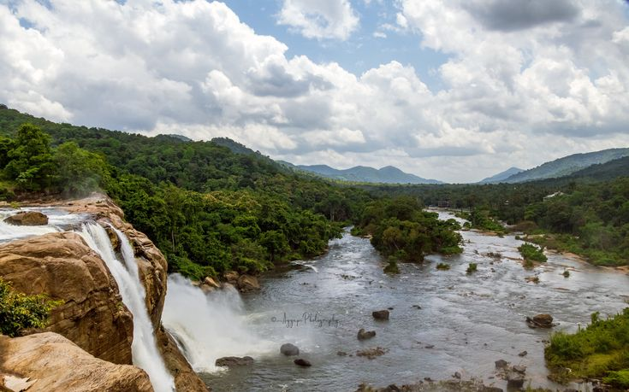
Morning after breakfast proceed for sightseeing tour of Munnar visiting Attukad Waterfalls – A Hidden Gem Amidst Munnar’s Green Hills : Discover the enchanting Attukad Waterfalls, located along the scenic Munnar–Pallivasal road, where cascading water descends gracefully through the verdant hills, resembling a delicate thread of pearls falling from the mountainside. Surrounded by rolling slopes, lush vegetation, and mist-covered landscapes, the falls offer a wonderfully serene setting and an excellent opportunity for photography. The journey to the waterfall is part of the experience. Cross a charming narrow wooden bridge, which is often enveloped in the cool mountain mist, before arriving at this picturesque natural retreat. Along the way, the surrounding forests and vegetation provide opportunities to observe a variety of fascinating flora and fauna native to the Western Ghats. A visit to Attukad Waterfalls is a delightful escape into nature, where mist, flowing water, lush forests, and rolling mountain scenery combine to create one of Munnar’s most picturesque and refreshing experiences

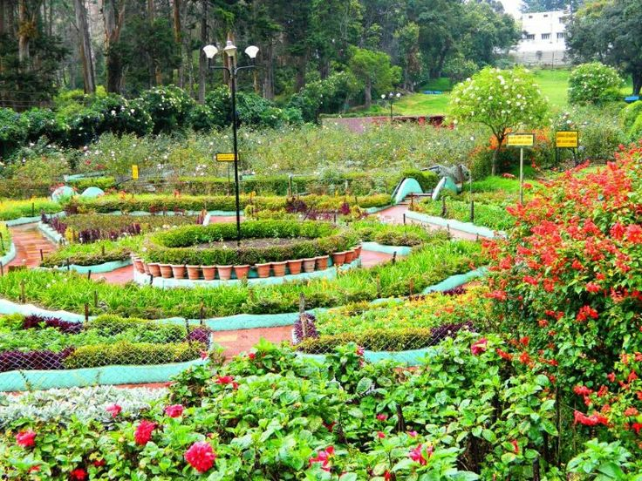
Munnar Rose Garden – A Floral Retreat Amidst the Hills: Set amidst the verdant landscapes of Munnar, close to the Kannan Devan Hills Tea Estates and the tranquil Muthirappuzha River, the Munnar Rose Garden forms part of the Sylvan Hill Resort and offers a delightful escape into nature. Spread across beautifully landscaped lawns and gardens, the garden is adorned with colourful blooms, charming animal sculptures, artificial waterfalls and a small aquarium, creating a picturesque setting for a leisurely visit. Stroll through the vibrant gardens and admire an enchanting collection of fresh flowers, while the cool mountain air and peaceful surroundings add to the experience. The garden also offers a variety of recreational activities, including nature walks, trekking, bird watching, boating, badminton and roller skating, making it an enjoyable stop for visitors of all ages.

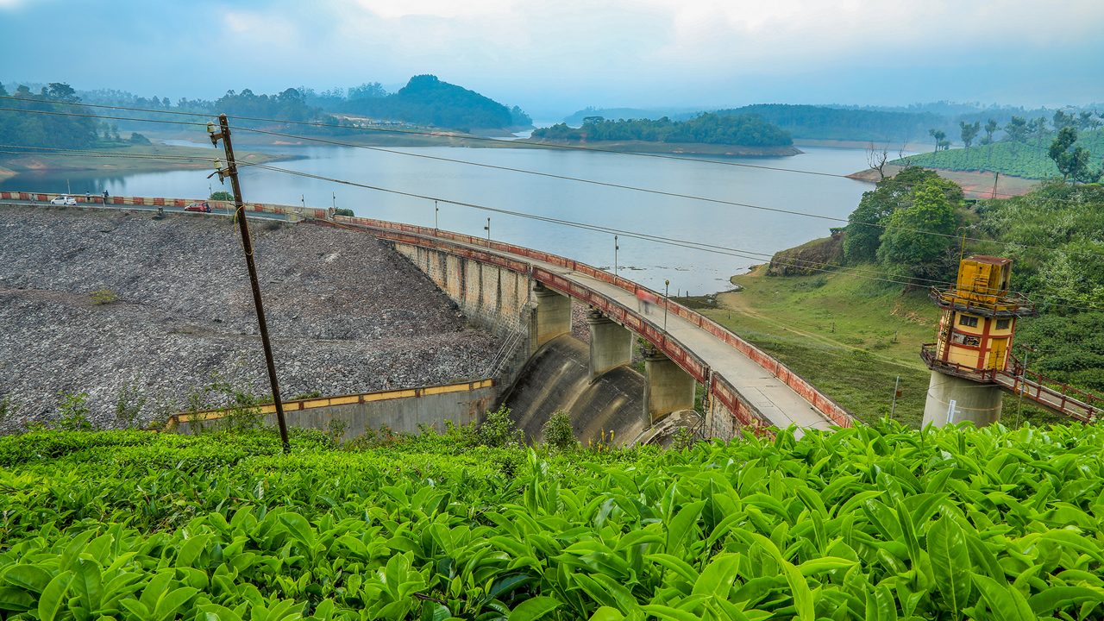
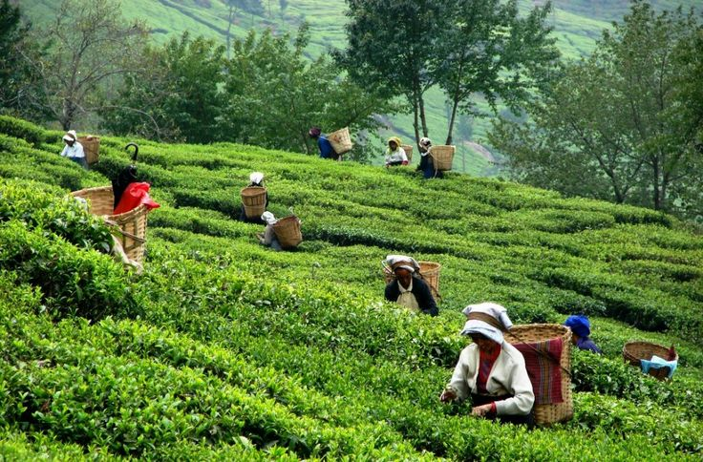
Mattupetty Tea Gardens – A Journey Through Munnar’s Tea Country: Nestled in the heart of Munnar’s renowned tea country, Mattupetty is surrounded by vast stretches of verdant tea gardens and plantations, creating one of the region’s most characteristic landscapes. The meticulously pruned tea bushes cascade gracefully across the rolling hills, while winding paths weave through the plantations, offering a wonderfully scenic setting to experience the charm of Kerala’s highlands. A visit to these plantations provides an opportunity to discover the fascinating journey of tea—from the careful cultivation of tender leaves to their processing and preparation. Guided plantation walks offer an engaging insight into traditional tea-growing practices while allowing visitors to appreciate the dedication and craftsmanship behind every cup. The experience is enhanced by the refreshing mountain air and the delicate, invigorating aroma of freshly grown tea leaves. Surrounded by endless shades of green, misty hills and panoramic vistas, a leisurely walk through the tea gardens becomes more than a sightseeing experience—it is an intimate encounter with Munnar’s landscape, culture and enduring tea-growing heritage.
Mattupetty Dam & Lake – Serenity Amidst Munnar’s Hills: Set amidst the picturesque highlands of Munnar, Mattupetty Dam and Lake are among the region’s most popular attractions, inviting visitors to slow down and enjoy the tranquil beauty of the surrounding landscape. Built in the late 1940s, the concrete gravity dam was developed for water conservation, hydroelectric power generation and irrigation, creating the scenic reservoir now known as Mattupetty Lake. Surrounded by rolling green hills, tea plantations and lush vegetation, the lake provides a wonderfully peaceful setting to appreciate Munnar’s natural beauty. Its calm waters mirror the surrounding landscape, creating a particularly picturesque atmosphere that is ideal for photography and moments of quiet relaxation.

Dinner and overnight stay at hotel in Munnar

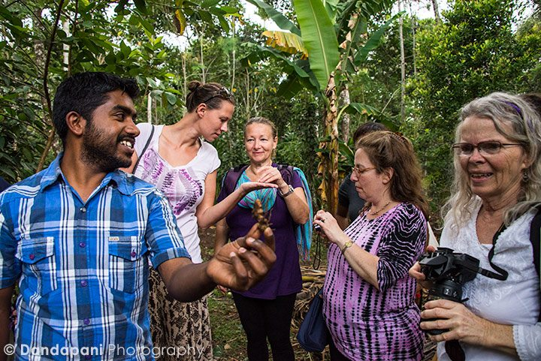
24 JUL’27 | DAY 13: | MUNNAR – PERIYAR (96Kms, 03Hrs drive)
Morning after breakfast drive to Periyar. Upon arrival check in at hotel in Periyar. Afternoon enjoy the Kumily Spice Plantations – A Fragrant Journey Through Kerala’s Spice Country: A walk through the streets of Kumily or along the winding pathways of its lush plantations is an experience guided as much by scent as by sight. The air is naturally infused with the distinctive aromas of cloves, nutmeg, pepper, cinnamon and cardamom, sometimes blending together to create an intoxicating fragrance that is unmistakably Kerala. The region’s cool climate, fertile soil and elevated terrain provide ideal conditions for cultivating some of India’s finest spices. Among the treasures of Kumily, cardamom holds a special place. Known as Elettaria cardamomum, the small cardamom variety flourishes in the shaded, humid conditions of the Western Ghats, generally at elevations of around 600 to 1,200 metres above sea level. The lush, shrub-like plants thrive beneath the forest canopy, producing the fragrant green pods that have made Kerala famous as one of the world’s traditional spice-growing regions. A visit to the spice plantations offers an opportunity to discover the fascinating world behind these everyday ingredients—from cultivation and harvesting to their traditional uses in cuisine, Ayurveda and local life. Walking amidst the plantations, surrounded by dense greenery and the lingering fragrance of freshly grown spices, provides a wonderfully immersive glimpse into the natural wealth and agricultural heritage of Kerala.

Dinner and overnight stay at hotel in Periyar

25 JUL’27 | DAY 14: | PERIYAR – ALLEPPEY (132Kms, 03Hrs drive)
Morning take a boat ride at Lake Periyar – A Scenic Cruise Through Kerala’s Wildlife Haven: Embark on a peaceful boat ride across Lake Periyar, one of the most enchanting ways to experience the natural beauty and wildlife of Thekkady. As the boat gently cruises along the tranquil waters and wooded shores, keep a watchful eye on the surrounding forest, where wildlife often appears along the banks and among the dense vegetation. The lake and its surrounding forests provide a natural habitat for a fascinating variety of wildlife. Elephants, gaur (Indian bison), sambar deer, wild boar, Nilgiri langurs, otters and the elusive flying squirrel are among the species that may be encountered during the cruise. Sightings are naturally dependent on the animals’ movements, making every boat ride a unique experience. The waters and forests of Periyar are equally rewarding for bird and butterfly enthusiasts, with around 246 species of birds and 112 species of butterflies recorded in the region. The gentle rhythm of the boat, the reflections of the forest-covered hills and the possibility of spotting wildlife along the shoreline combine to create a wonderfully tranquil and memorable encounter with Kerala’s wilderness. A cruise on Lake Periyar is therefore more than a sightseeing excursion—it is an opportunity to immerse yourself in the quiet rhythm of nature and discover the remarkable biodiversity of the Western Ghats.

Later continue drive to Alleppey jetty point to board the houseboat. Upon arrival check in at the houseboat.

Lunch, Dinner and overnight stay at houseboat

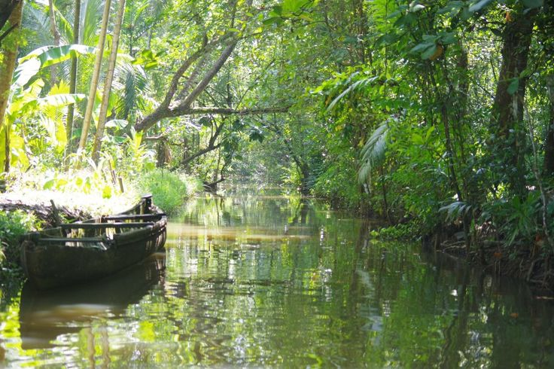
26 JUL’27 | DAY 15: | ALLEPPEY – KUMARAKOM (37Kms, 01Hrs drive)
Morning after breakfast drive to Kumarakom. Upon arrival check in at hotel in Kumarakom. Later proceed to visit Kumarakom Bird Sanctuary – A Haven for Avian Life: Discover the tranquil Kumarakom Bird Sanctuary, set along the lush banks of Lake Vembanad, Kerala’s largest lake. The story of this enchanting sanctuary dates back to 1847, when Alfred George Baker began transforming the wetlands of what is now Kumarakom into fertile land. Of the extensive property granted to him by the local ruler, he left a portion of the southern bank of the River Kavanar untouched, planting mangroves across approximately 10 acres. Over time, this undisturbed wetland environment became a natural refuge for both resident and migratory birds. What began as an untouched stretch of mangrove habitat gradually evolved into the bird sanctuary known today as the Vembanad Bird Sanctuary. The sanctuary now encompasses approximately 14 acres and provides a protected habitat for a remarkable diversity of birdlife, with around 180 species recorded in the region. The sanctuary’s exceptional avian diversity is closely linked to its unique natural setting. Its proximity to the vast waters of Lake Vembanad, combined with fertile wetlands, abundant insects, rich vegetation, and preserved mangrove ecosystems, creates an ideal environment for birds throughout the year.

Afternoon enjoy the village tour of Kumarakom.

Dinner and overnight stay at hotel in Kumarakom

27 JUL’27 | DAY 16: | KUMARAKOM – KOVALAM (179Kms, 05Hrs drive)
Morning after breakfast drive to Kovalam. Upon arrival check in at hotel in Kovalam.

Later proceed for Ayurveda Therapy.

Lunch, Dinner and overnight stay at hotel in Kovalam

28 JUL’27 | DAY 17: | KOVALAM
Enjoy Ayurveda Therapy in Kovalam

Breakfast, Lunch, Dinner and overnight stay at hotel in Kovalam

29 JUL’27 | DAY 18: | KOVALAM
Enjoy Ayurveda Therapy in Kovalam

Breakfast, Lunch, Dinner and overnight stay at hotel in Kovalam

30 JUL’27 | DAY 19: | KOVALAM – TRIVANDRUM – DEPART TRIVANDRUM
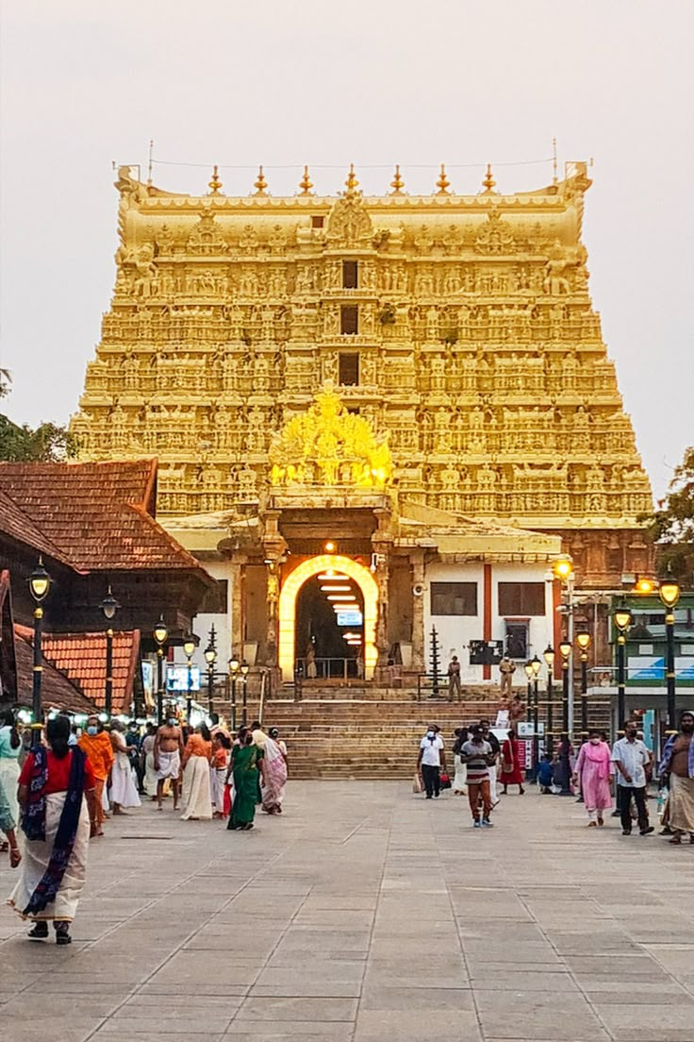
Morning after breakfast check out from the hotel and proceed for sightseeing tour of Trivandrum – Heritage, Art and Royal Elegance: Embark on a half-day sightseeing tour of Trivandrum, the elegant capital of Kerala, where centuries-old traditions, royal heritage, art, and natural beauty come together to create a fascinating introduction to the region. Begin with a visit to the magnificent Sri Padmanabhaswamy Temple, an iconic landmark of Trivandrum with a history spanning more than two centuries. Dedicated to Lord Vishnu, the temple is renowned for its imposing Dravidian-style architecture, richly carved details, and profound spiritual significance. Entry into the temple is restricted to Hindus. Continue to the Napier Museum, an impressive Indo-Saracenic structure housing an exceptional collection of archaeological and artistic treasures, including traditional bronzes, sculptures, ivory carvings, and other works representing Kerala’s rich cultural heritage. Adjacent to the museum, visit the Sri Chitra Art Gallery, celebrated for its distinguished collection of Indian paintings. The gallery offers an enriching insight into the country’s artistic traditions, with works representing classical, modern, and regional schools of Indian art. The Napier Museum and Sri Chitra Art Gallery are closed on Monday and Wednesday mornings. The sightseeing continues with the Zoological Gardens and Reptile House, offering an opportunity to discover Kerala’s diverse wildlife in a verdant setting. Conclude the cultural exploration with a visit to the Observatory, one of the city’s historic landmarks associated with the study and observation of the skies. Also visit the graceful Kanakakunnu Palace, an elegant former royal venue admired for its distinctive Indo-Saracenic architecture, ornamental stucco work, graceful domes, and beautifully crafted arches. Set amidst attractive landscaped surroundings, the palace provides a glimpse into the refined lifestyle and architectural heritage of the erstwhile Travancore royal era.

Later drop at airport to board flight for onward destination.

END OF THE SERVICES

TOUR COST:
CATEGORY | COST PER PERSON
Towards the cost for North & South India tour | Euro 1807 per person
Single Room Supplement | USD 571 per Single

CiTY | HOTEL 4 STAR | LINKS | NIGHTS
Delhi | Park Inn By Radisson IP Extension or similar | Park Inn By Radisson IP Extension | 02 Night
Varanasi | Hotel Tridev or similar | Hotel Tridev Varanasi | 02 Night
Khajuraho | Ramada By Wyndham or similar | Ramada By Wyndham | 01 Night
Orchha | Orchha Palace or similar | Orchha Palace | 01 Night
Agra | Grand Mercure or similar | Grand Mercure | 01 Night
Jaipur | Sunday Hotel or similar | Sunday Hotel | 02 Night
Cochin | Crown Plaza or similar | Crown Plaza Kochi | 01 Night
Munnar | The Leaf or similar | The Leaf Munnar | 02 Night
Periyar | Elephant Court or similar | Elephant Court | 01 Night
Alleppey | Luxury Houseboat | Luxury Houseboat | 01 Night
Kumarakom | Lake Song or similar | Lake Song | 01 Night
Kovalam | Travencore Heritage or similar | The Travencore Heritage | 03 Night
Total, number of nights |  |  | 18 Nights

Air:
Date | Sector | Flight | Departure | Arrival | Fare
21 Jul’27 | Jaipur – Cochin | 6E 6142 | 08:35Hrs | 14:00Hrs | Euro 153 per person

*******Air Fare are subject to change without notice*******

Our prices include:

Accomodation based on Double room.

Half Board basis as per program (Breakfast, Dinner) and full board in Kovalam and House boat (Breakfast, Lunch, Dinner) and

All arrival/departure transfer, sightseeing tour excursions by Air-conditioned Tempo Traveller.

Entrance fees to Monuments

Italian speaking guide as per program except in Kovalam and Trivandrum for sightseeing of Trivandrum

Aarti ceremony in Varanasi

Early Morning boat ride in Varanasi

Elephant ride at Amer Fort in Jaipur

Spice plantation tour in Periyar

Boat ride at Lake Periyar

Daily Yoga in Morning and Meditation in the Evening

Ayurveda meals

Daily doctor ’s consultation

Daily at 14:30Hrs treatment (As per doctor ‘s prescription)

Village tour of Kumarakom

Train tickets for travel sector Varanasi to Khajuraho by Vande Bharat Express in Air-Conditioned Chair car

Train tickets for travel sector Jhansi to Agra by Vande Bharat Express in Air-Conditioned Chair car

02 night in Delhi with breakfast and Dinner basis.

02 night in Varanasi with breakfast and Dinner basis.

01 night in Khajuraho with breakfast and Dinner basis.

01 night in Orchha with breakfast and Dinner basis.

01 night in Agra with breakfast and Dinner basis.

02 night in Jaipur with breakfast and Dinner basis.

01 night in Cochin with breakfast and Dinner basis.

02 night in Munnar with breakfast and Dinner basis.

01 night in Periyar with breakfast and Dinner basis.

01 night in House boat with full board basis.

03 Nights in Kovalam with full board basis

Government tax.

Our prices do not include:

Air fare

Entry visa.

Visas can be obtained online at: www.indianvisaonline.gov.in

Tips for guides (at the client's discretion).

Travel and cancellation insurance (optional).

Beverages.

Any services not mentioned as included, including personal extras such as telephone calls, laundry

service, etc.

